RadBot - Detecting objects using ultrasonic sound waves

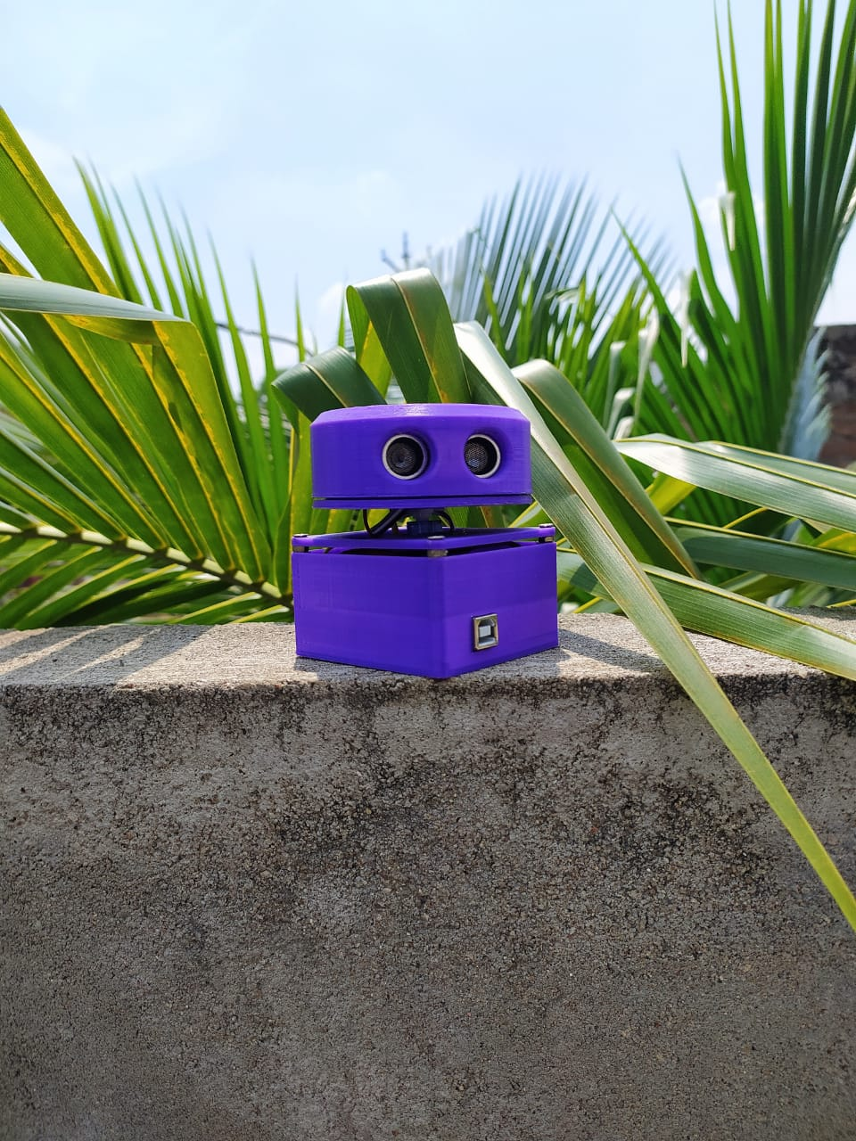

Just like radars that use radio waves and lidars that use light, this project uses ultrasonic sound waves to detect objects around us.

Components used -

1. Arduino uno x 1

2. Servo SG90 x 1

3. Ultrasonic modules x 2

4. 3d printer parts

5. Bolts

Note- You will need access to 3d printer to build the radar enclosure

This is a simple project that uses two ultrasonic sensor modules mounted on a servo motor that rotates between 0 and 180°. These two ultrasonic modules are mounted opposite to each other so that we can get a complete 360° view. All the magic is done with the help of Arduino UNO.

We use Arduino UNO to control servos and receive data from ultrasonic sensors. Then the data is sent to the computer connected Arduino UNO, which reads as well as processes the data and lastly displays a 2D image with the help of custom build software.

Here we are using 9g servo with 180° rotation and is controlled by the PWM pin of Arduino UNO.

This process starts with a test rotation of servo motor, it will go from 0 to 180° then 180° to 0. Subsequently, the servo rotates degree by degree so ultrasonic modules can send ultrasonic sound waves or echoes to help determine the distance of an object.

This is similar to the concept of RADAR but instead of electromagnetic signals here we are using ultrasonic sound waves. As we know the speed of sound we can easily determine how far or near the object is to the ultrasonic modules by using the formula - Distance = speed x time.

The data from both sensors will be sent over USB connected Arduino to an application on your PC, which stores the data in an array that is interpreted to display by a 2D plane.

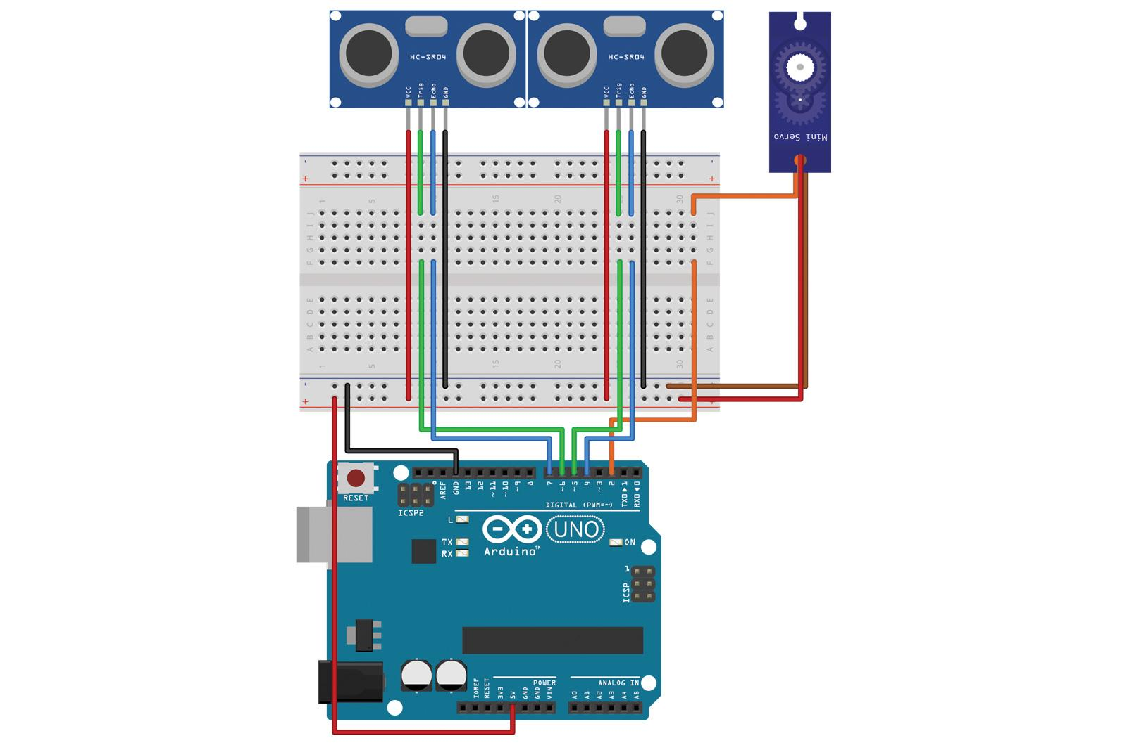

This is the circuit diagram to test if the system is working. Later we will remove the breadboard and do the connections directly as shown:

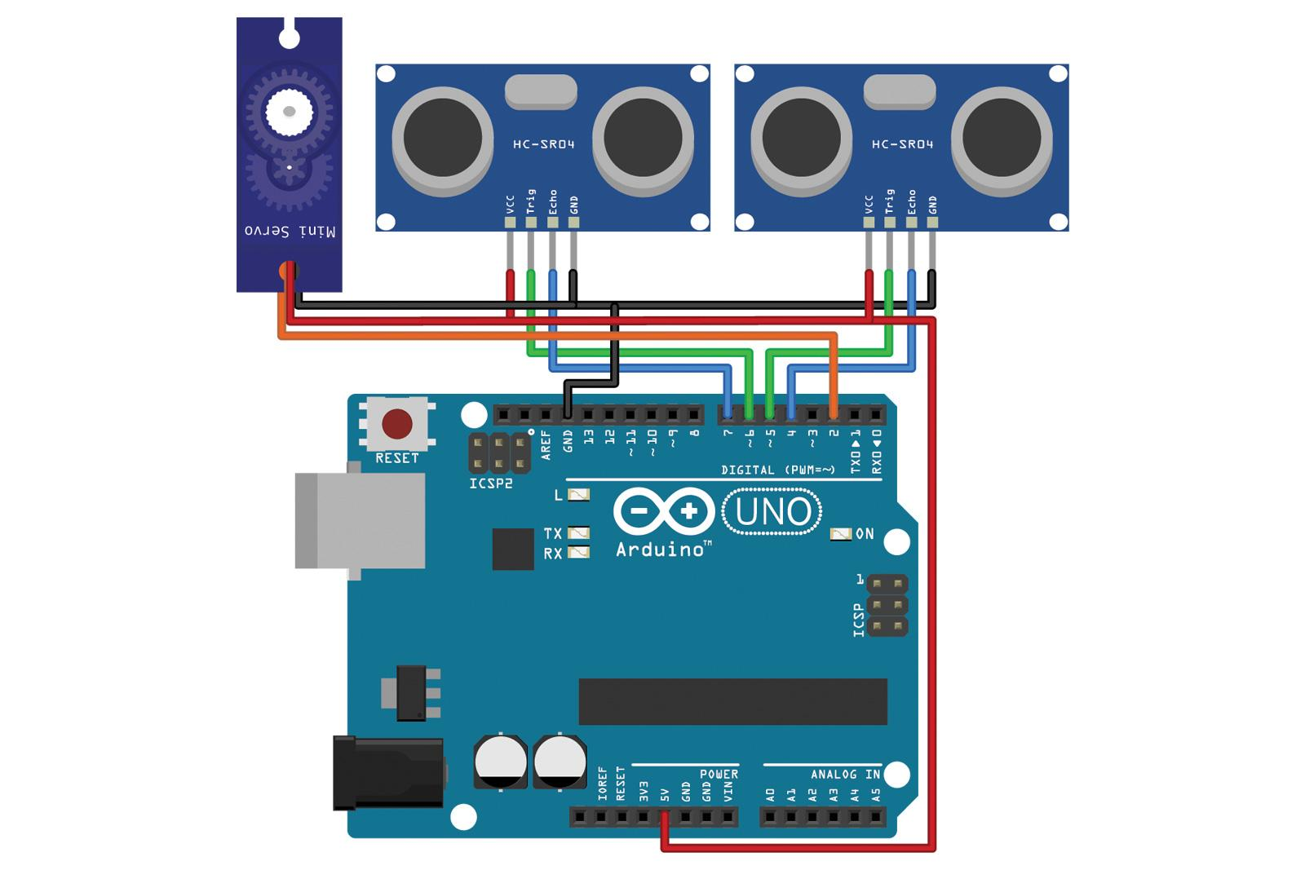

Steps for execution:

1. Download the arduino code from the link : <https://github.com/Martinsos/arduino-lib-hc-sr04>
2. Upload this code in your Arduino UNO and servo will start rotating.
3. Now download this app <https://processing.org/download/> and launch the processing program.
4. For assembly, more detailed instructions and troubleshooting please visit the original creators post link given below:

<https://diyodemag.com/projects/on_the_radar_ultrasonic_radar_with_arduino>